**Host a Dynamic Website on AWS EC2 using S3 to store source code.**

*The developers of the company have given you code for a dynamic website (users are able to log into) that needs to be deployed onto a server.*

In the console, navigate to the Amazon S3 service and **create a bucket to store the code** that the developers have given for the company’s dynamic website.

*\*\* Remember Bucket name must be globally unique\*\**

Upload the website source code files into the created bucket.

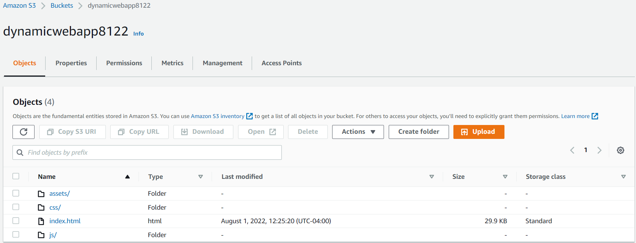

Create IAM role that enables EC2 to talk to S3.

* *AmazonS3FullAccess*

(Disregard the SSM policy for this project)

**Launch EC2 instance**

Attach the created IAM role to the instance.

**Security Group should allow access to HTTP port 80, HTTPS port 443, and SSH port 22 (my ip)**

**Install Apache server to host application**

Access the EC2 instance via SSH (or *AWS Systems Manager*)

Switch over to the ec2-user

* sudo su ec2-user

Execute these commands to install Apache:

* sudo yum update -y
* sudo amazon-linux-extras install -y lamp-mariadb10.2-php7.2 php7.2
* sudo yum install -y httpd mariadb-server
* sudo systemctl start httpd
* sudo systemctl enable httpd
* sudo systemctl is-enabled httpd

The website source code needs to be copied from the S3 bucket into the /var/www/html folder created by Apache in order to be accessed by the world.

* sudo aws s3 cp s3://dynamicwebapp8122 --region us-east-1 /var/www/html/ --recursive

Access dynamic website via the public ipv4 address of the EC2 instance.